function measureExecutionTime(queryFunction, description) {

const startTime = new Date();

const result = queryFunction();

const endTime = new Date();

const executionTime = endTime - startTime;

print(description);

print(`Execution time: ${executionTime} ms`);

if (result !== undefined) {

printjson(result);

}

}

**Task01**

Update the First Element in an Array Inside a Nested Object

Objective: Modify the first element of the dose_schedule array within treatment details for a specified appointment.

SQL:

UPDATE Appointments

SET dose_day_1 = 3

WHERE appointment_id = 2;

SELECT appointment_id,dose_day_1

FROM Appointments

WHERE appointment_id = 2;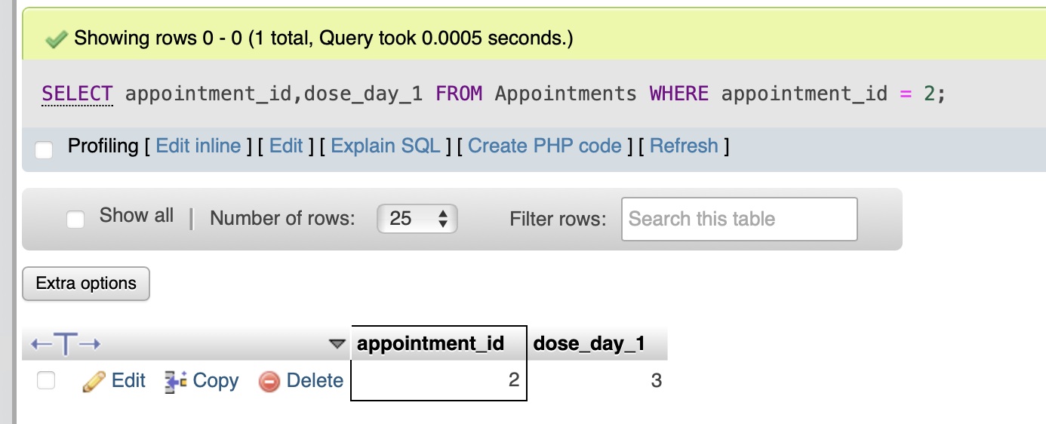

MongoDB:

function updateDoseSchedule(appointmentId) {

// Start measuring time

const startTime = new Date();

// Find the specified appointment by its _id

let appointment = db.Appointments.findOne({ _id: appointmentId });

if (!appointment) {

print("Appointment not found.");

return;

}

// Print the dose schedule before the update

print("Before Update - Dose Schedule:", appointment.treatment_details.dose_schedule);

// Update the first element of the dose_schedule array

db.Appointments.updateOne(

{ _id: appointmentId },

{ $set: { "treatment_details.dose_schedule.0": 3 } } // Set the first dose to '3'

);

// Find the updated appointment

let updatedAppointment = db.Appointments.findOne({ _id: appointmentId });

// Print the dose schedule after the update

print("After Update - Dose Schedule:", updatedAppointment.treatment_details.dose_schedule);

// Stop measuring time

const endTime = new Date();

const executionTime = endTime - startTime;

print(`Execution time: ${executionTime} ms`);

}

// Call the function with a specific appointment _id

updateDoseSchedule(2);

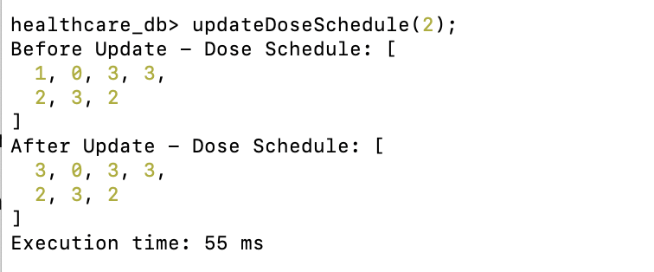

**Task02**

Retrieve Patients with Specific Criteria

Objective: Find and list all patients who are either under 20 years old or over 50 years old, and who either have a contact number or an email address.

SQL:

SELECT *

FROM Patients

WHERE (age < 20 OR age > 50)

AND (contact_number IS NOT NULL OR email IS NOT NULL);

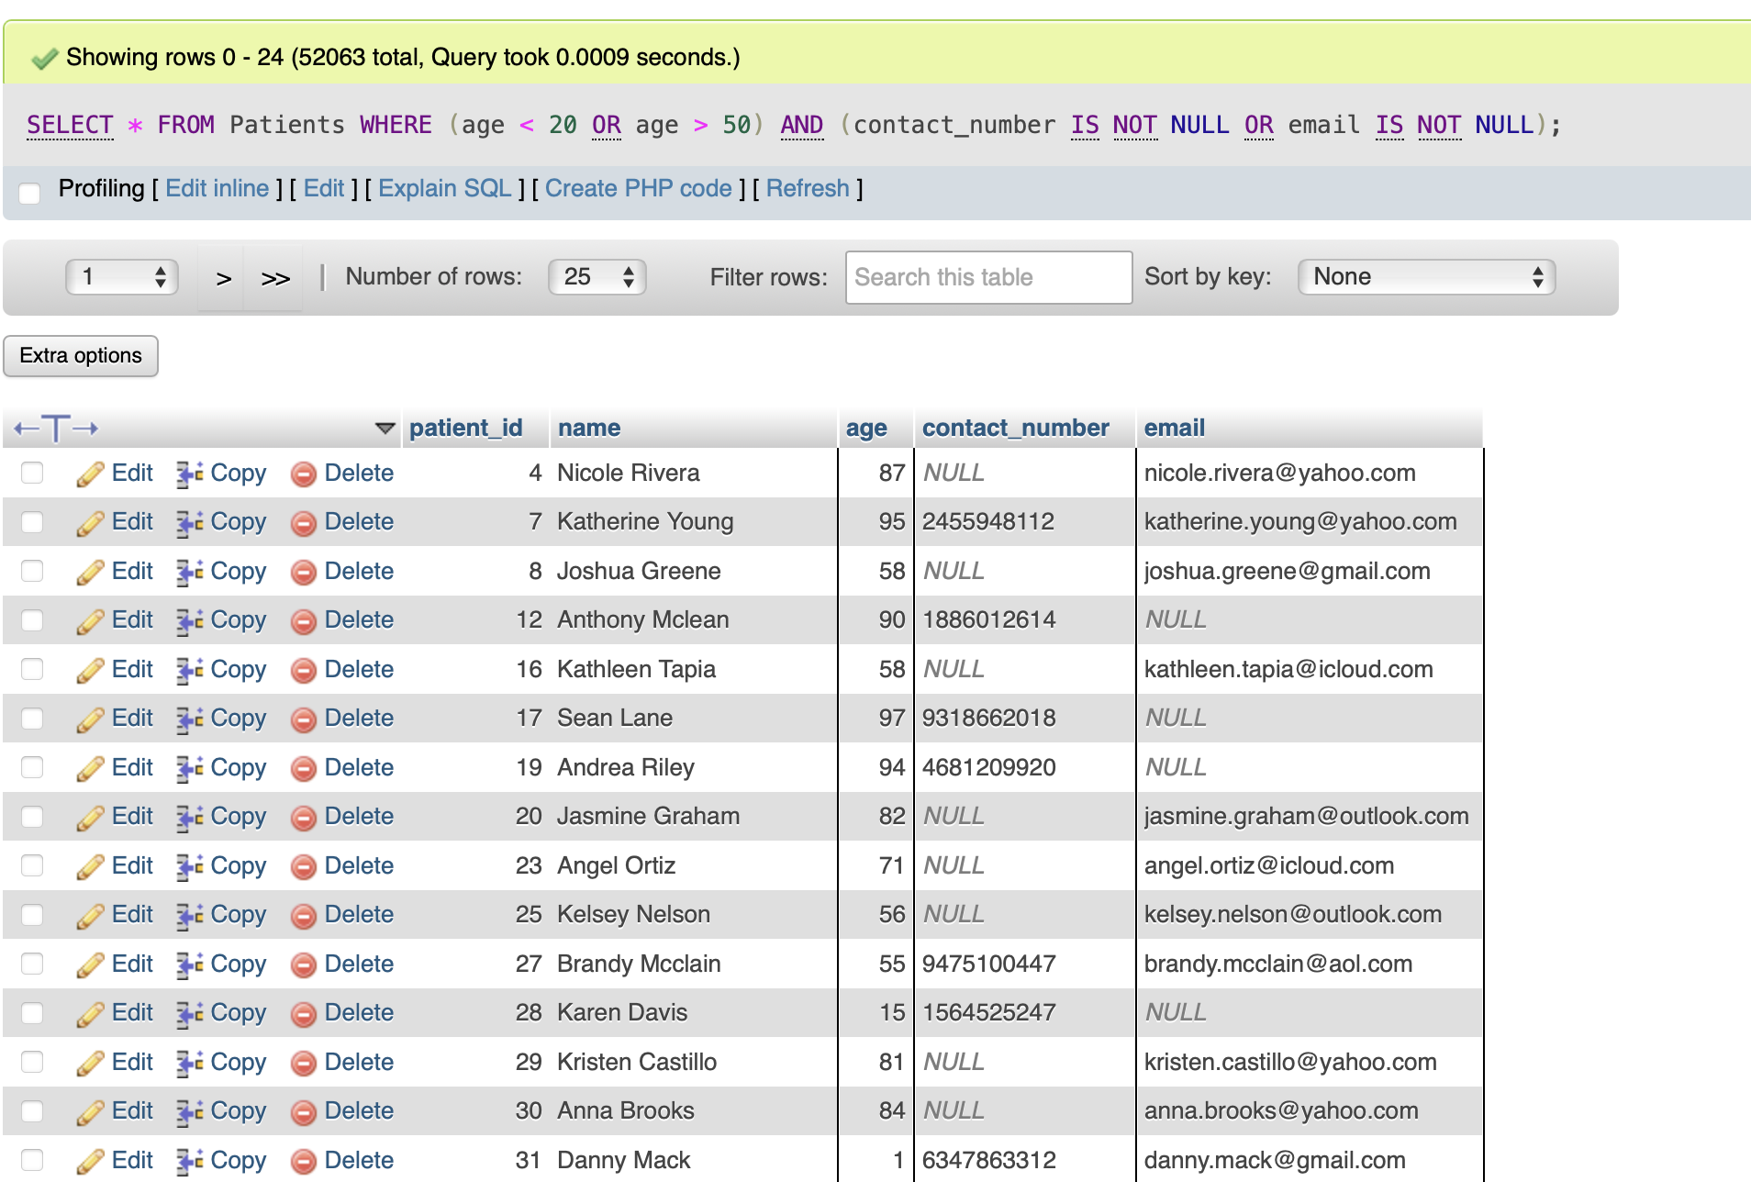

MongoDB:

function findPatientsWithCriteria() {

return db.Patients.find({

$and: [

{ $or: [{ age: { $lt: 20 } }, { age: { $gt: 50 } }] },

{ $or: [{ contact_number: { $ne: null } }, { email: { $ne: null } }] }

]

}).toArray();

}

measureExecutionTime(findPatientsWithCriteria, "Patients matching criteria for Task 2:");

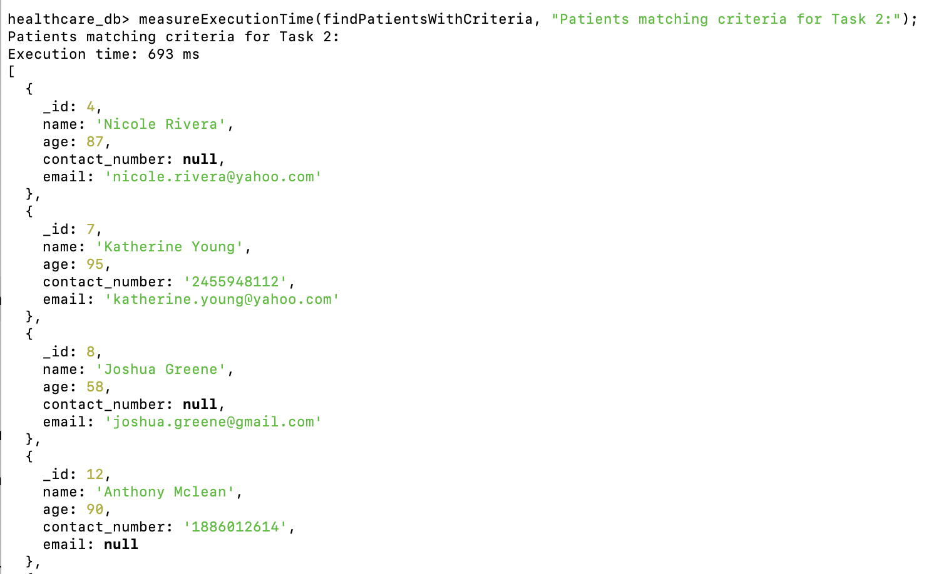

**Task03**

Increase Age by 1 Year for All Patients Over 60

Objective: Increment the age of all patients over 60 by 1 year.

SQL:

UPDATE Patients

SET age = age + 1

WHERE age > 60;

SELECT *

FROM Patients

WHERE age > 60;

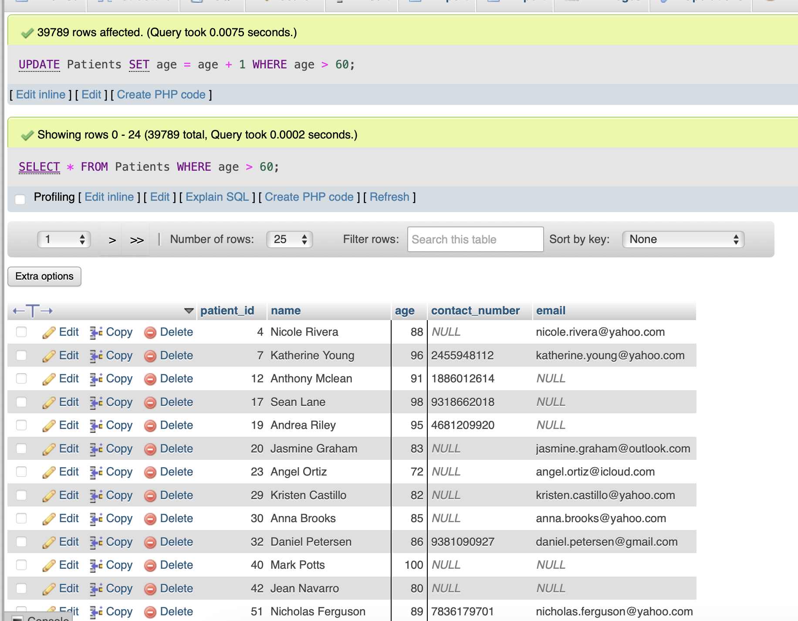

MongoDB:

function incrementAgeForPatientsOver60() {

// Start measuring time

const startTime = new Date();

// Find patients over age 60 and print their ages before update

let patientsBeforeUpdate = db.Patients.find({ age: { $gt: 60 } }).limit(5).toArray();

print("Before Update - Sample of Ages:");

patientsBeforeUpdate.forEach(patient => {

print(`Patient ID: ${patient._id}, Age: ${patient.age}`);

});

// Update the age of patients over 60 by incrementing by 1

db.Patients.updateMany(

{ age: { $gt: 60 } },

{ $inc: { age: 1 } }

);

// Find the updated patients and print their updated ages

let patientsAfterUpdate = db.Patients.find({ age: { $gt: 60 } }).limit(5).toArray();

print("After Update - Sample of Updated Ages:");

patientsAfterUpdate.forEach(patient => {

print(`Patient ID: ${patient._id}, Age: ${patient.age}`);

});

// Stop measuring time

const endTime = new Date();

const executionTime = endTime - startTime;

print(`Execution time: ${executionTime} ms`);

}

// Call the function

incrementAgeForPatientsOver60();

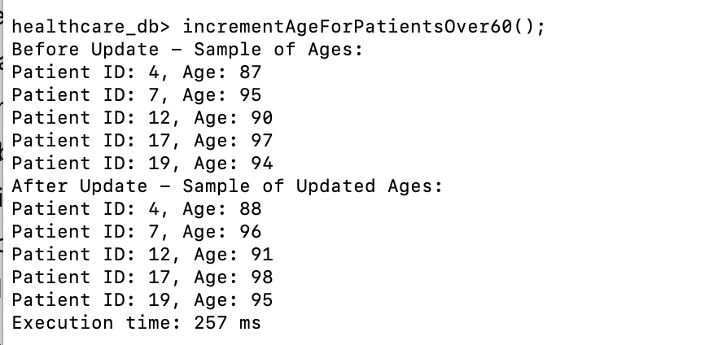

**Task04**

Perform Aggregation to Count Appointments by Patient

Objective: Count the number of appointments each patient has had.

SQL:

SELECT patient_id, COUNT(*) AS total_appointments

FROM Appointments

GROUP BY patient_id;

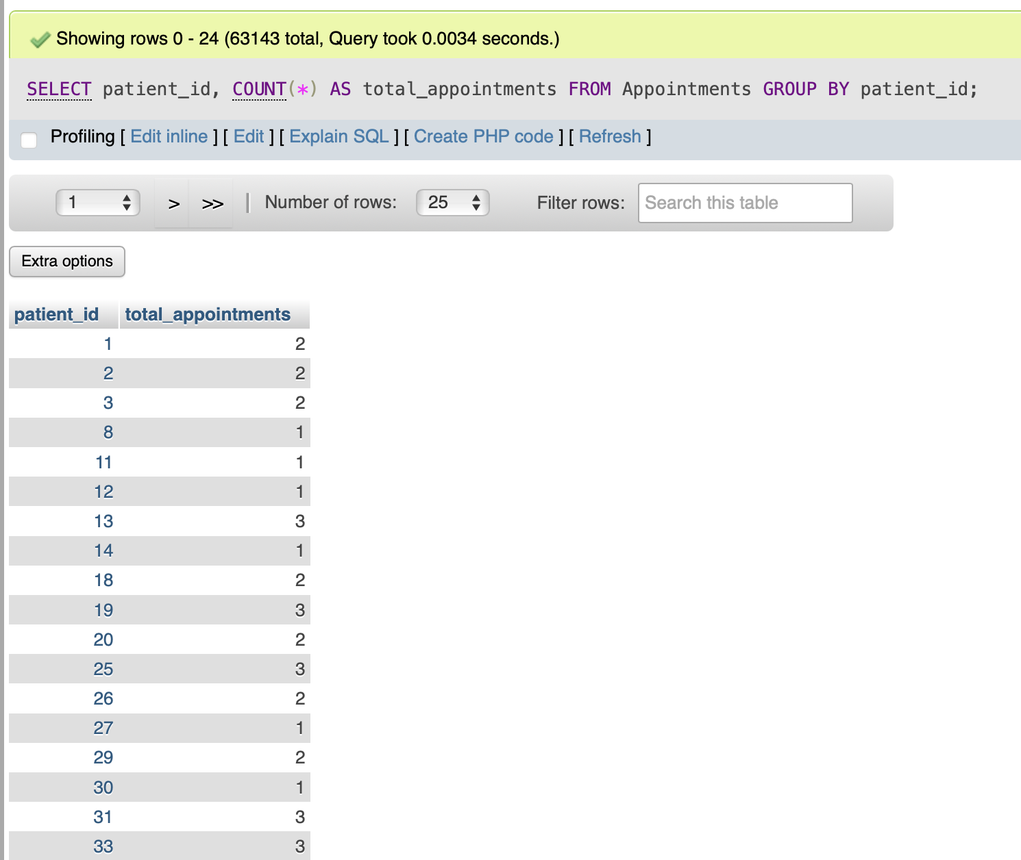

MongoDB:

function countAppointmentsByPatient() {

return db.Appointments.aggregate([

{ $group: { _id: "$patient_id", total_appointments: { $sum: 1 } } }

]).toArray();

}

measureExecutionTime(countAppointmentsByPatient, "Appointment Count by Patient for Task 4:");

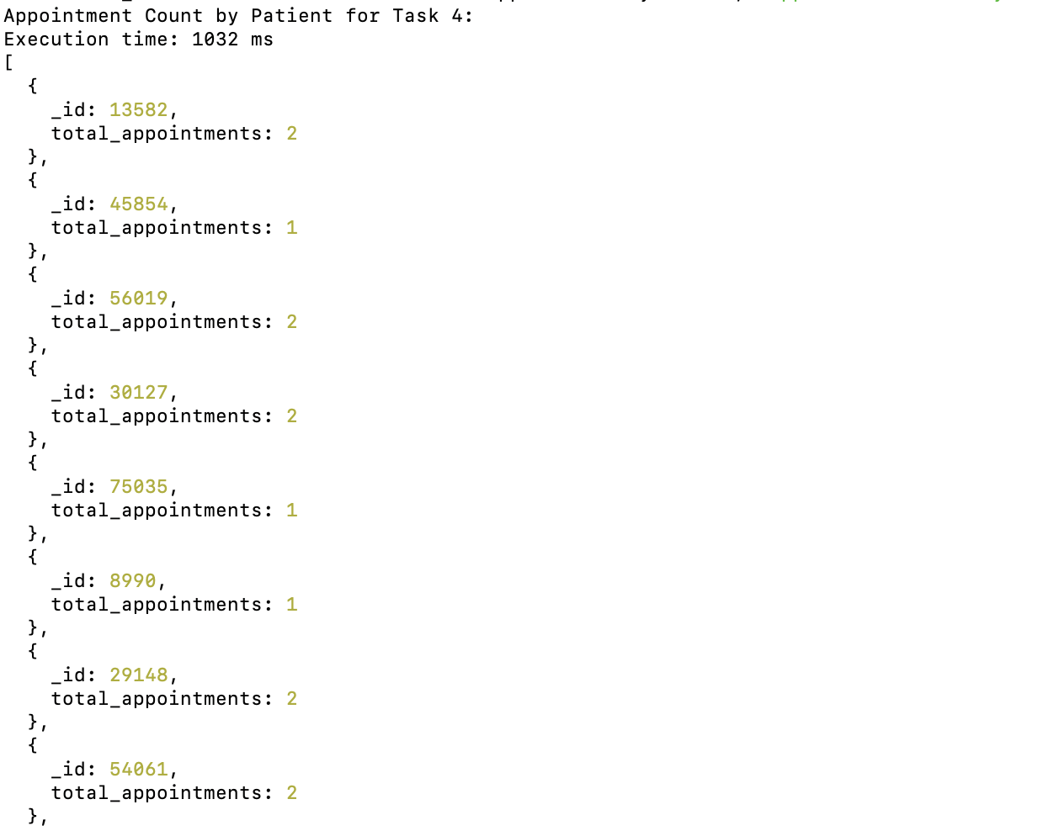

**Task05**

Find Appointments with Symptoms Containing "fever" but Not "cough"

Objective: Identify and retrieve appointments where the symptoms include "fever" but exclude "cough".

SQL:

SELECT patient_id, symptom1, symptom2

FROM Appointments

WHERE (symptom1 = 'fever' OR symptom2 = 'fever')

AND (symptom1 != 'cough' AND symptom2 != 'cough');

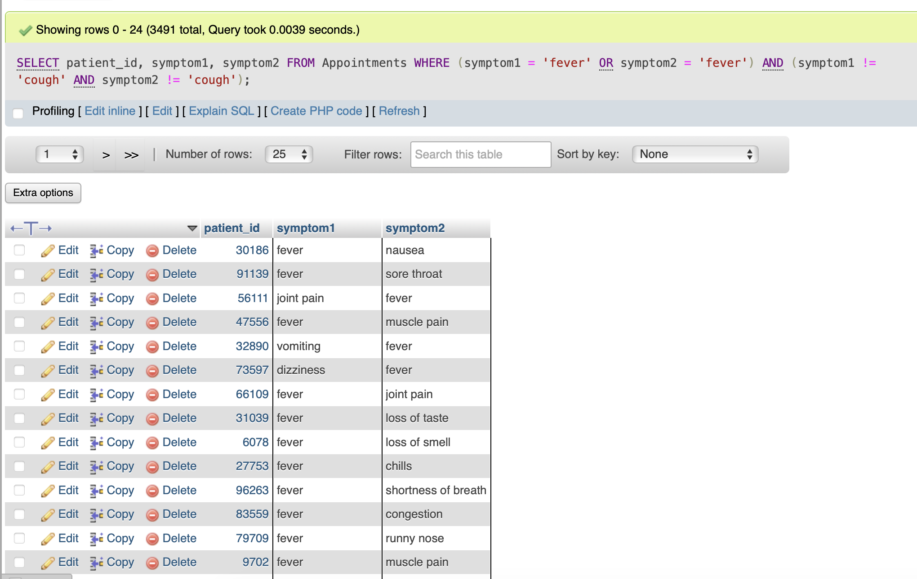

MongoDB:

function findAppointmentsWithFeverWithoutCough() {

return db.Appointments.find({

symptoms: { $all: ["fever"], $nin: ["cough"] }

}, {

patient_id: 1,

symptoms: 1,

_id: 0

}).toArray();

}

measureExecutionTime(findAppointmentsWithFeverWithoutCough, "Appointments with fever but no cough for Task 5:");

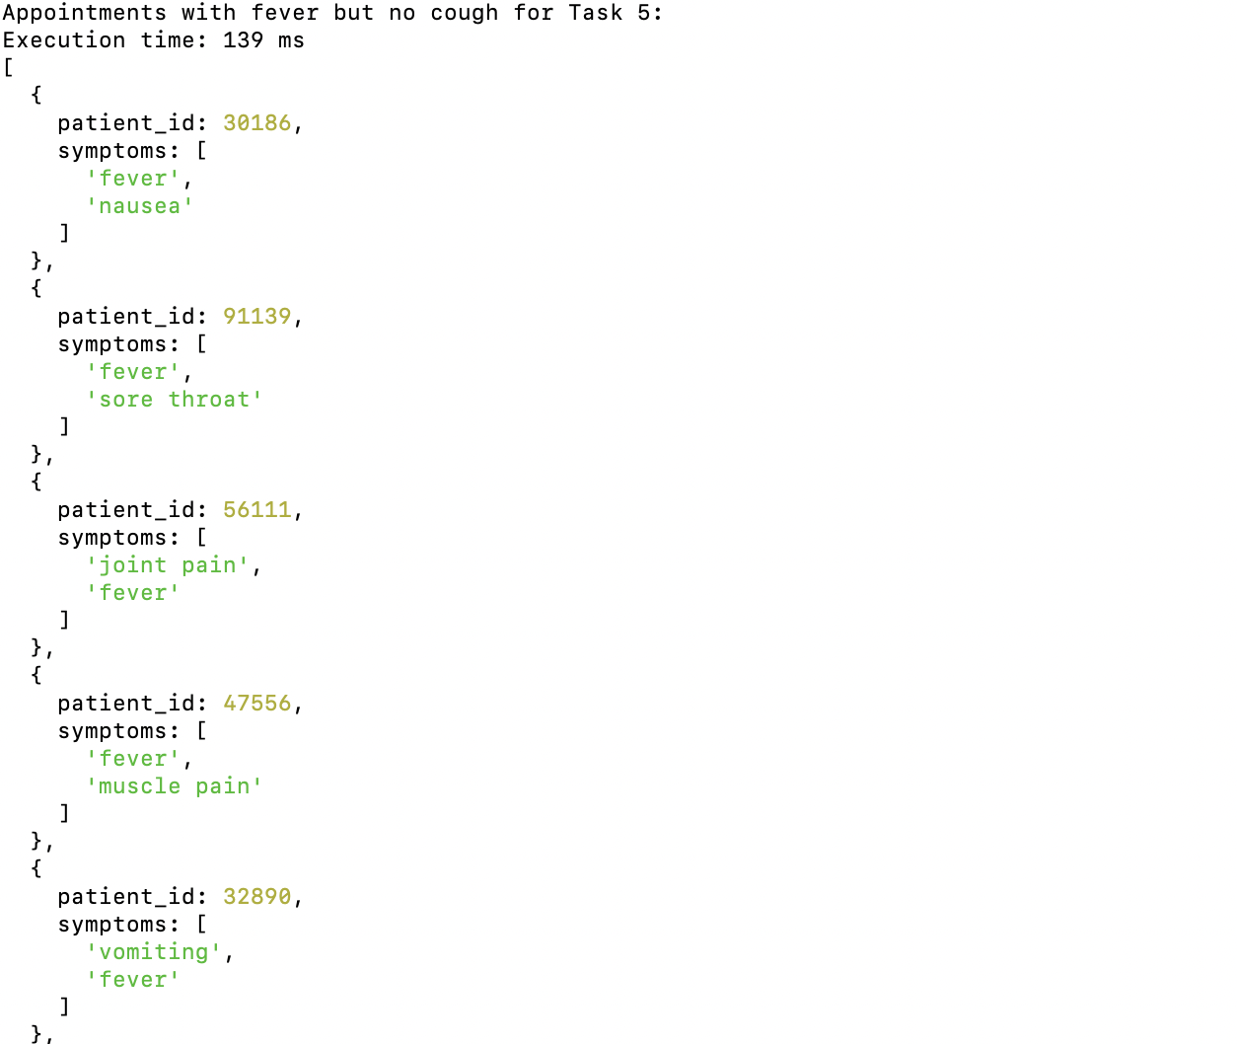

**Task06**

Retrieve Patients with Email Addresses from Gmail

Objective: Filter and retrieve patients whose email addresses are hosted on Gmail.

SQL:

SELECT patient_id, name, email

FROM Patients

WHERE email LIKE '%@gmail.com';

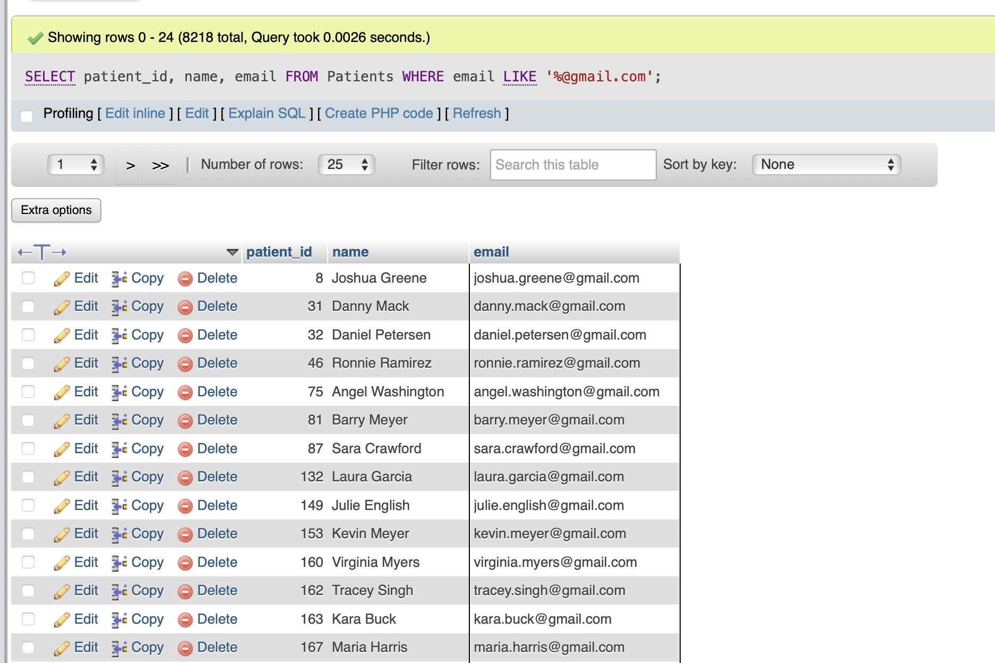

MongoDB:

function findPatientsWithGmail() {

return db.Patients.find({

email: /@gmail\.com$/

}, {

patient_id: 1,

name: 1,

email: 1,

_id: 0

}).toArray();

}

measureExecutionTime(findPatientsWithGmail, "Patients with Gmail addresses for Task 6:");

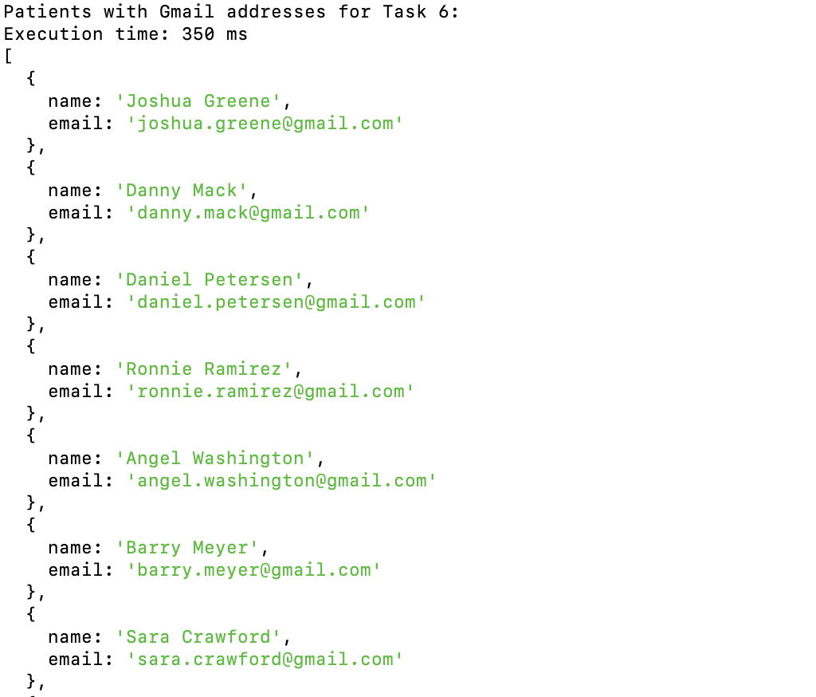

Task07

List Appointments Where More Than One Symptom Was Reported (Extra credit)

Objective: Gather and display appointments that have recorded more than one symptom.

SQL:

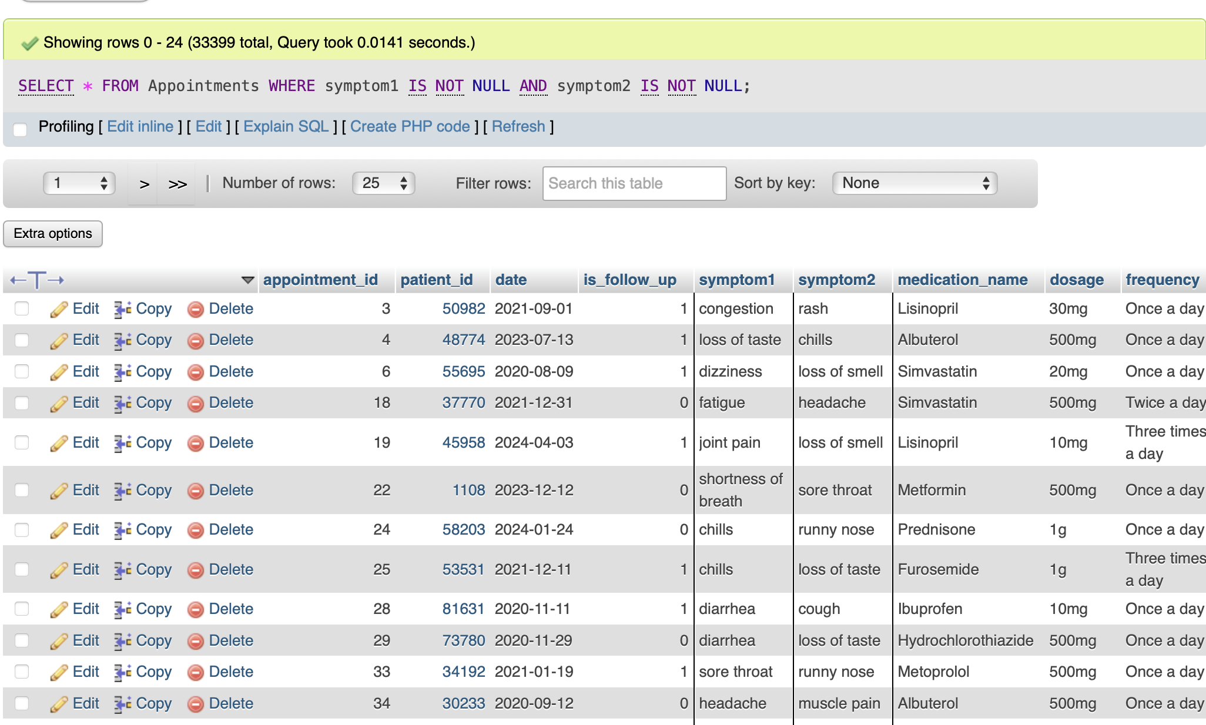

SELECT *

FROM Appointments

WHERE symptom1 IS NOT NULL AND symptom2 IS NOT NULL;

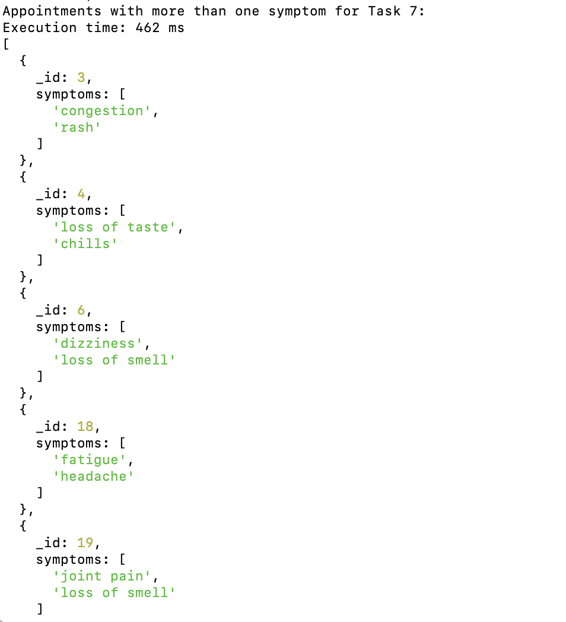

Task08

Remove Appointments with No Reported Symptoms

Objective: Delete all appointment records that lack any reported symptoms to maintain data quality.

SQL:

DELETE FROM Appointments

WHERE symptom1 IS NULL AND symptom2 IS NULL;

SELECT *

FROM Appointments;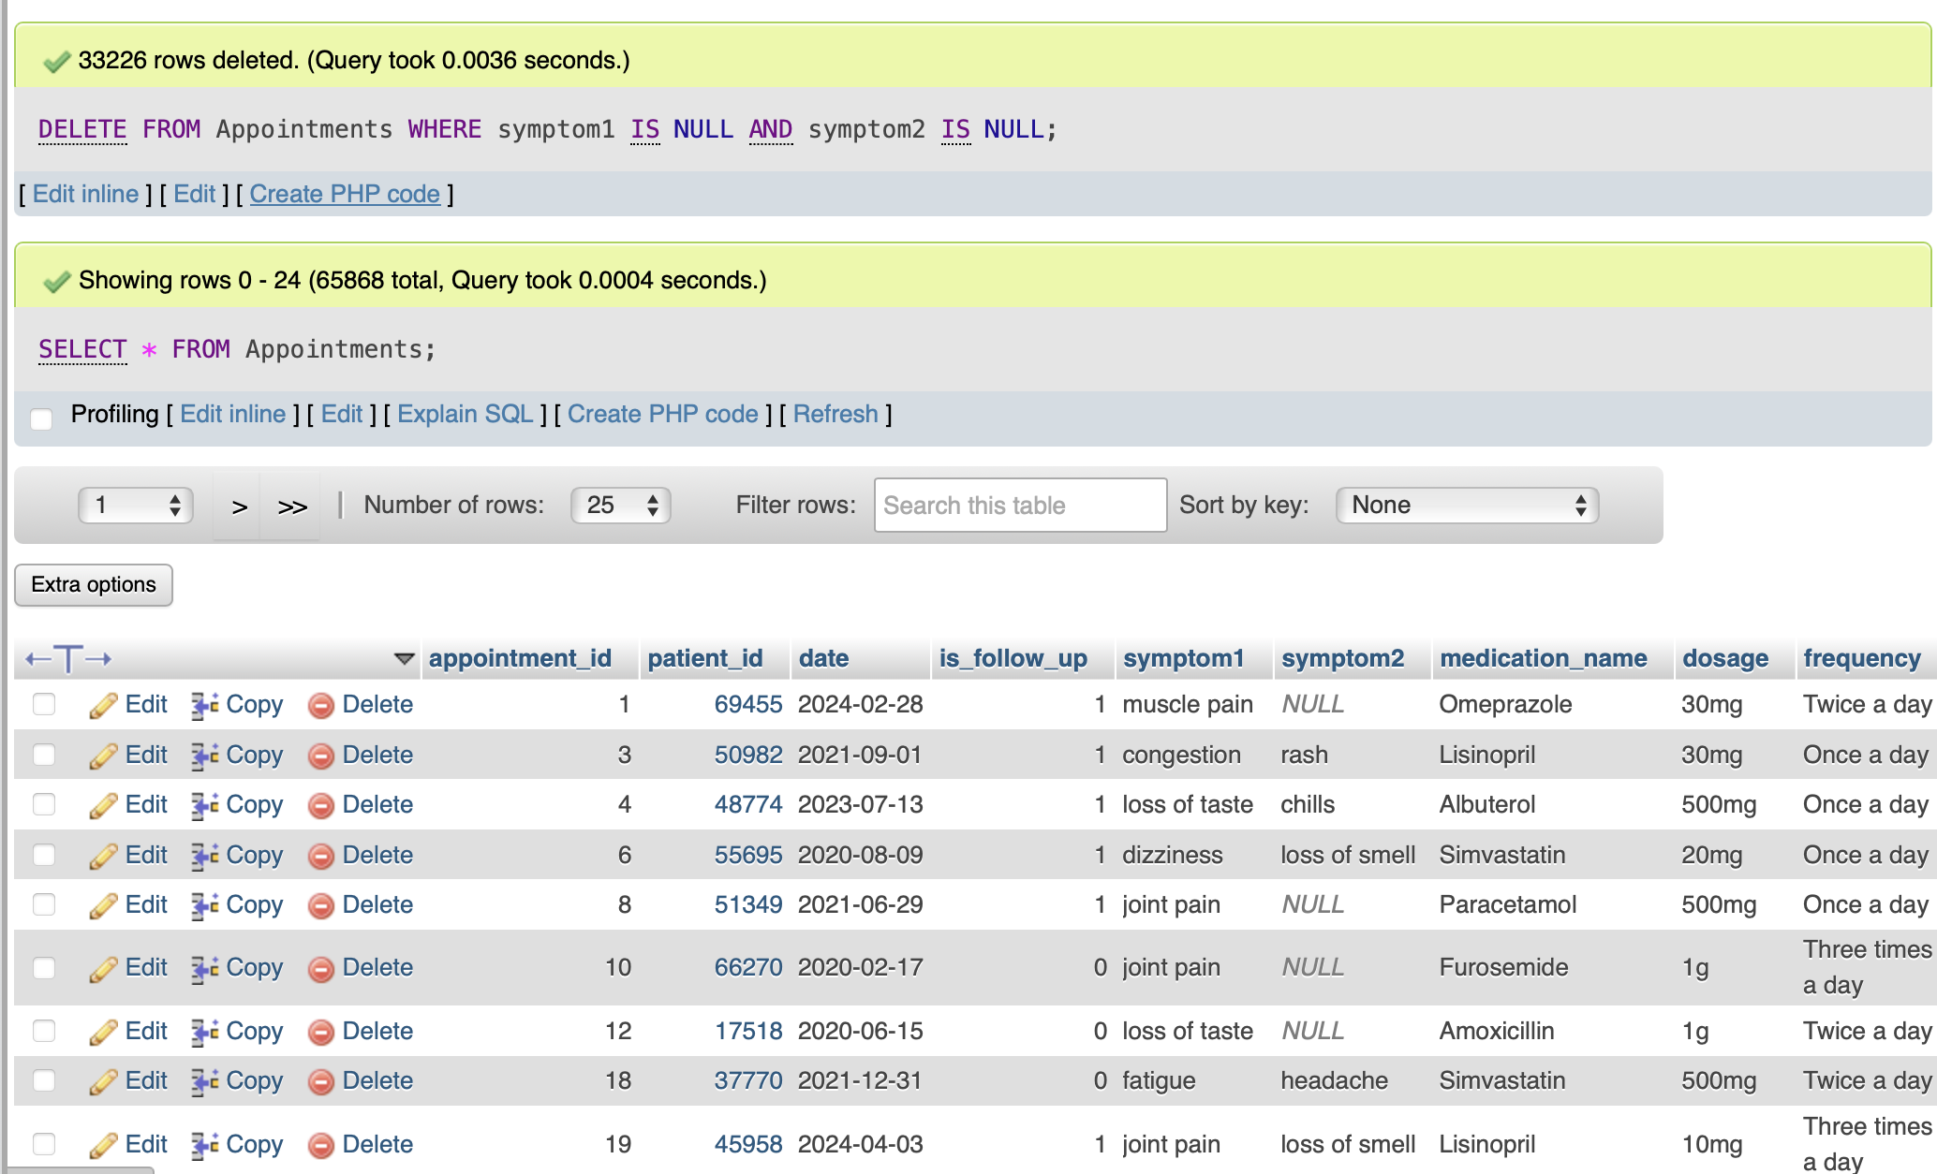

MongoDB: function deleteAppointmentsWithoutSymptoms() {

const startTime = new Date();

// Delete appointment records that lack any reported symptoms, including null or empty arrays

const deleteResult = db.Appointments.deleteMany({

$or: [

{ symptoms: { $exists: false } }, // Field doesn't exist

{ symptoms: { $size: 0 } }, // Field is an empty array

{ symptoms: null } // Field is explicitly null

]

});

print(`Number of appointments deleted: ${deleteResult.deletedCount}`);

const endTime = new Date();

const executionTime = endTime - startTime;

print(`Execution time: ${executionTime} ms`);

}

// Call the function

deleteAppointmentsWithoutSymptoms();



Task09

Retrieve Distinct Appointment Dates

Objective: Collect and display a list of unique appointment dates from the appointments collection.

SQL:

SELECT DISTINCT date

FROM Appointments;

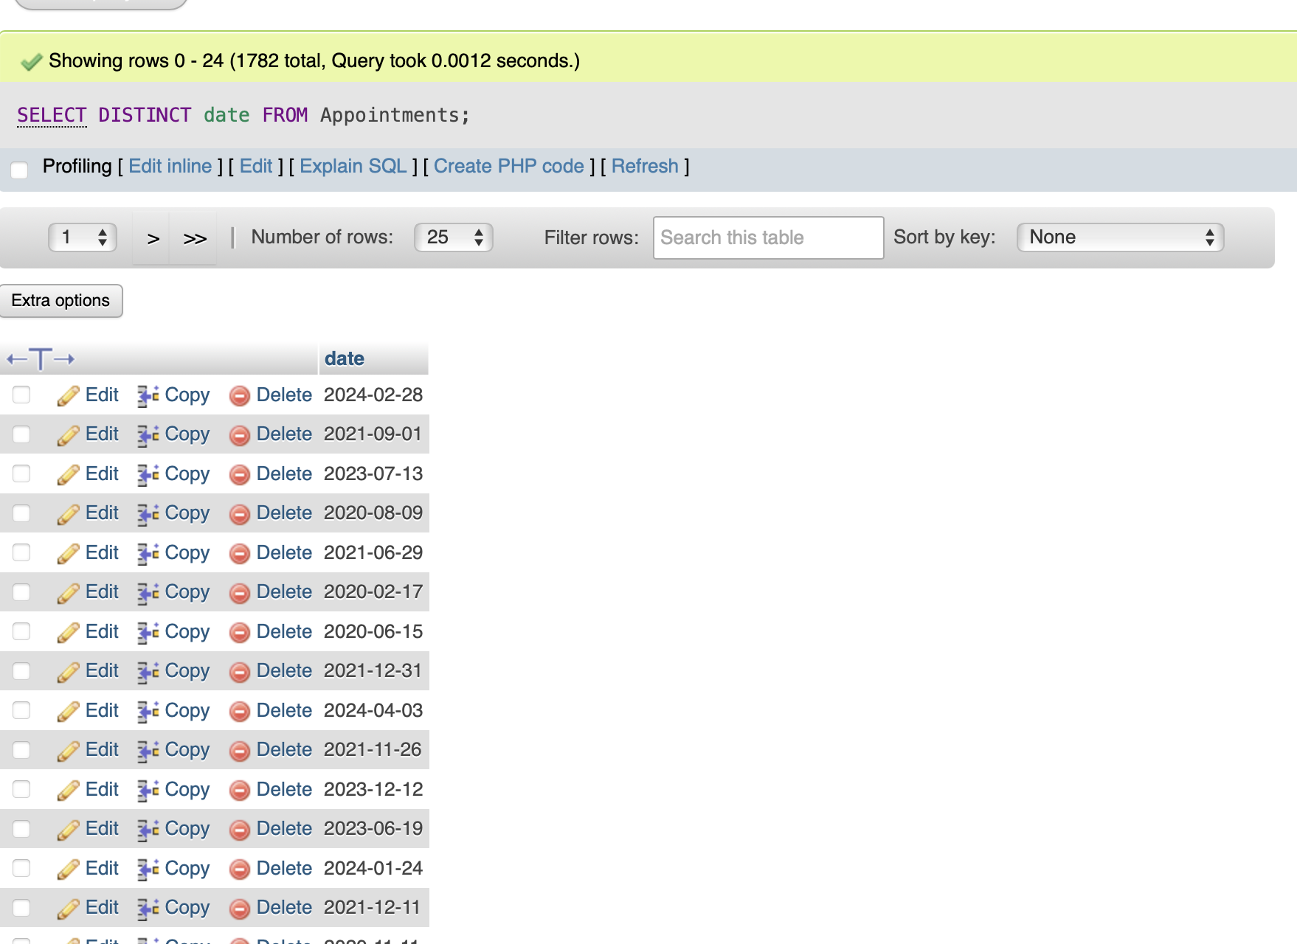

MongoDB:

function getDistinctAppointmentDates() {

const startTime = new Date();

// Retrieve distinct appointment dates from the Appointments collection

const distinctDates = db.Appointments.distinct("date");

print("Distinct appointment dates:");

distinctDates.forEach(date => print(date));

const endTime = new Date();

const executionTime = endTime - startTime;

print(`Execution time: ${executionTime} ms`);

}

// Call the function

getDistinctAppointmentDates();

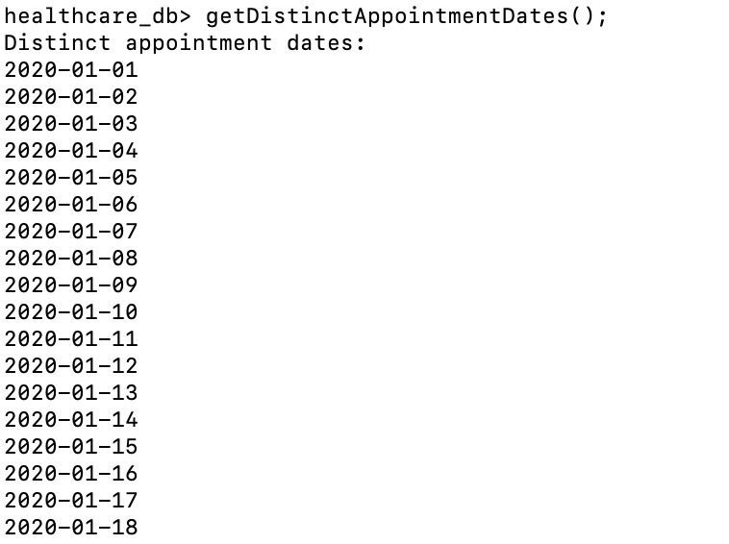

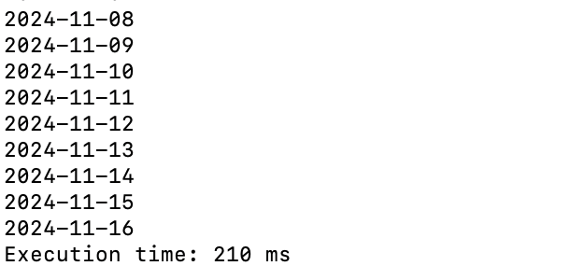

Task10

Delete Patients Over Age 60 with No Email

Objective: Remove patients from the database who are over 60 years old and do not have an email address.

SQL: DELETE FROM Appointments

WHERE patient_id IN (

SELECT patient_id

FROM Patients

WHERE age > 60 AND (email IS NULL OR email = '')

);

-- Now delete the patients

DELETE FROM Patients

WHERE age > 60 AND (email IS NULL OR email = '');

-- Print the remaining patients

SELECT *

FROM Patients;

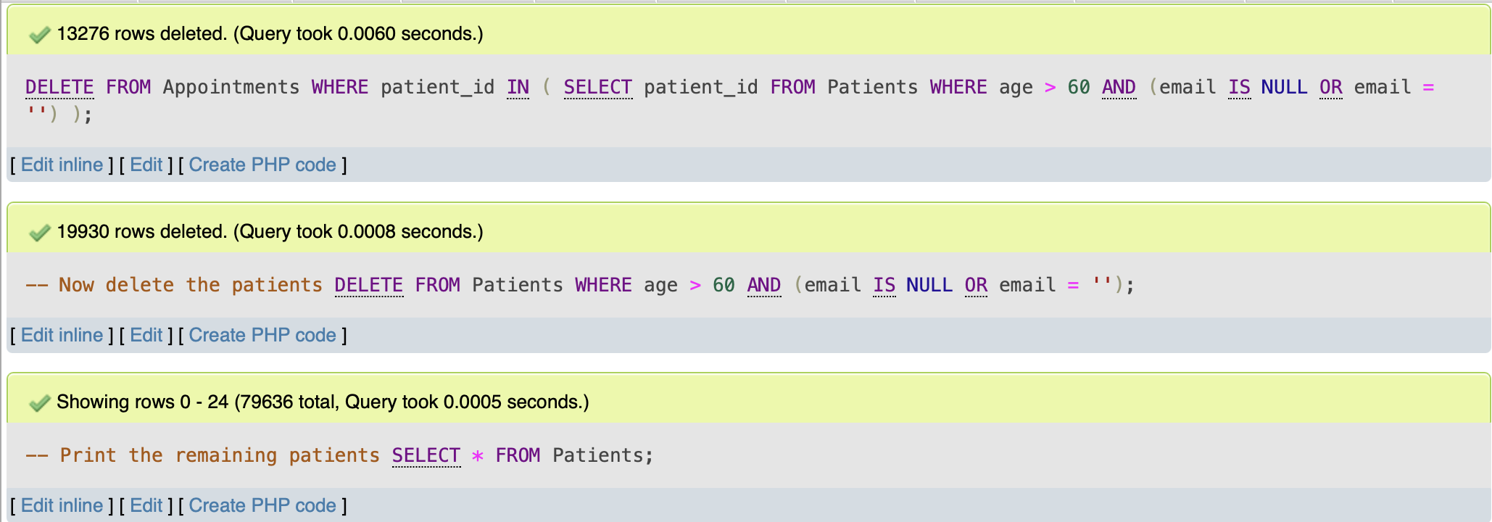

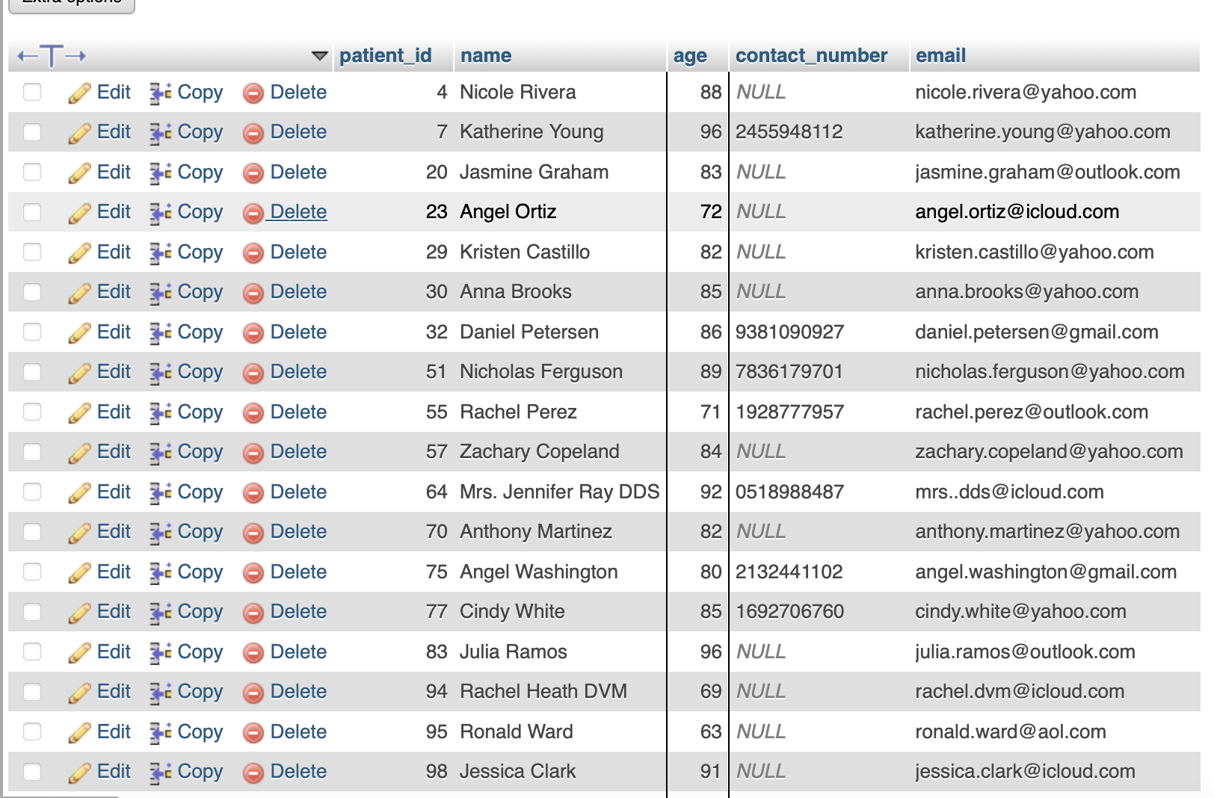

MongoDB:

function deletePatientsOver60WithoutEmail() {

const startTime = new Date();

// Find patients over age 60 who do not have an email address

const patientsToDelete = db.Patients.find({

age: { $gt: 60 },

$or: [

{ email: { $exists: false } },

{ email: null }

]

}).limit(5).toArray(); // Retrieve a sample of patients to be deleted

// Print 5 examples of patients to be deleted

print("Sample of patients to be deleted:");

patientsToDelete.forEach(patient => {

printjson(patient);

});

// Delete patients over age 60 who do not have an email address

const deleteResult = db.Patients.deleteMany({

age: { $gt: 60 },

$or: [

{ email: { $exists: false } },

{ email: null }

]

});

// Print the number of deleted records

print(`Number of patients deleted: ${deleteResult.deletedCount}`);

const endTime = new Date();

const executionTime = endTime - startTime;

print(`Execution time: ${executionTime} ms`);

}

// Call the function

deletePatientsOver60WithoutEmail();

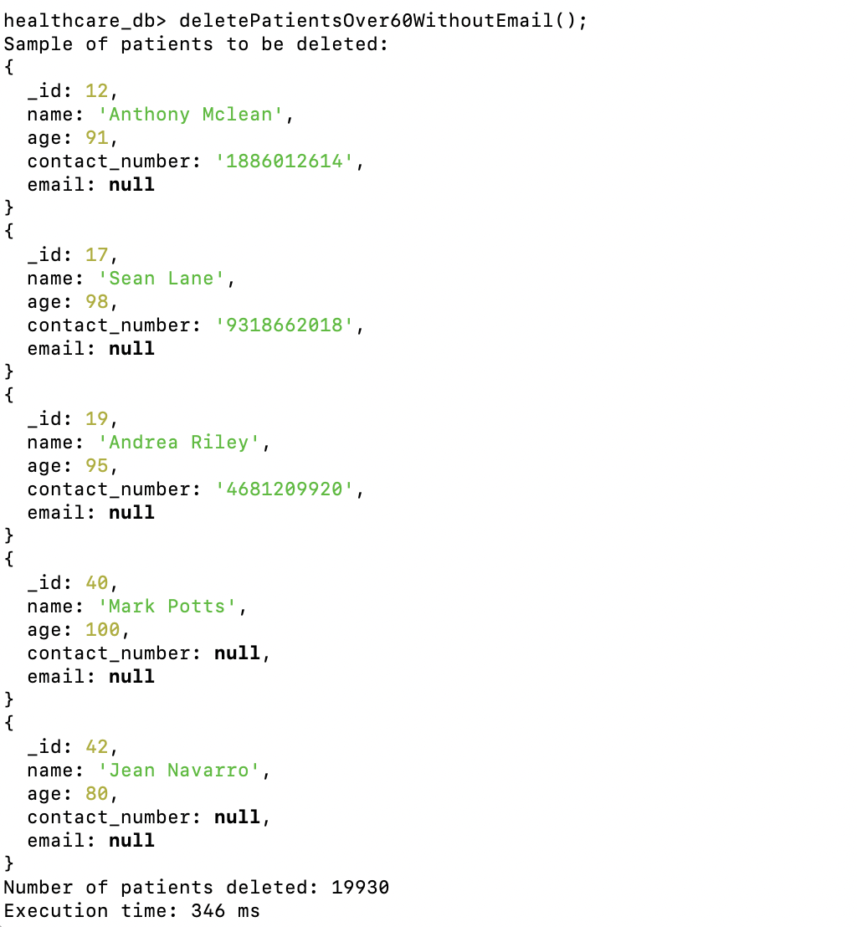

Task11

Retrieve Patients Aged Between 30 and 50 with Contact Information (Extra credit)

Objective: Get patient details, including contact information, for individuals aged between 30 and 50.

function retrievePatientsWithContactInfo() {

const startTime = new Date();

// Find patients aged between 30 and 50 with contact information

const patients = db.Patients.find({

age: { $gte: 30, $lte: 50 },

$or: [

{ contact_number: { $ne: null } },

{ email: { $ne: null } }

]

}).toArray();

// Print patient details

print("Patients aged between 30 and 50 with contact information:");

patients.forEach(patient => {

printjson({

_id: patient._id,

name: patient.name,

age: patient.age,

contact_number: patient.contact_number,

email: patient.email

});

});

const endTime = new Date();

const executionTime = endTime - startTime;

print(`Execution time: ${executionTime} ms`);

}

// Call the function

retrievePatientsWithContactInfo();

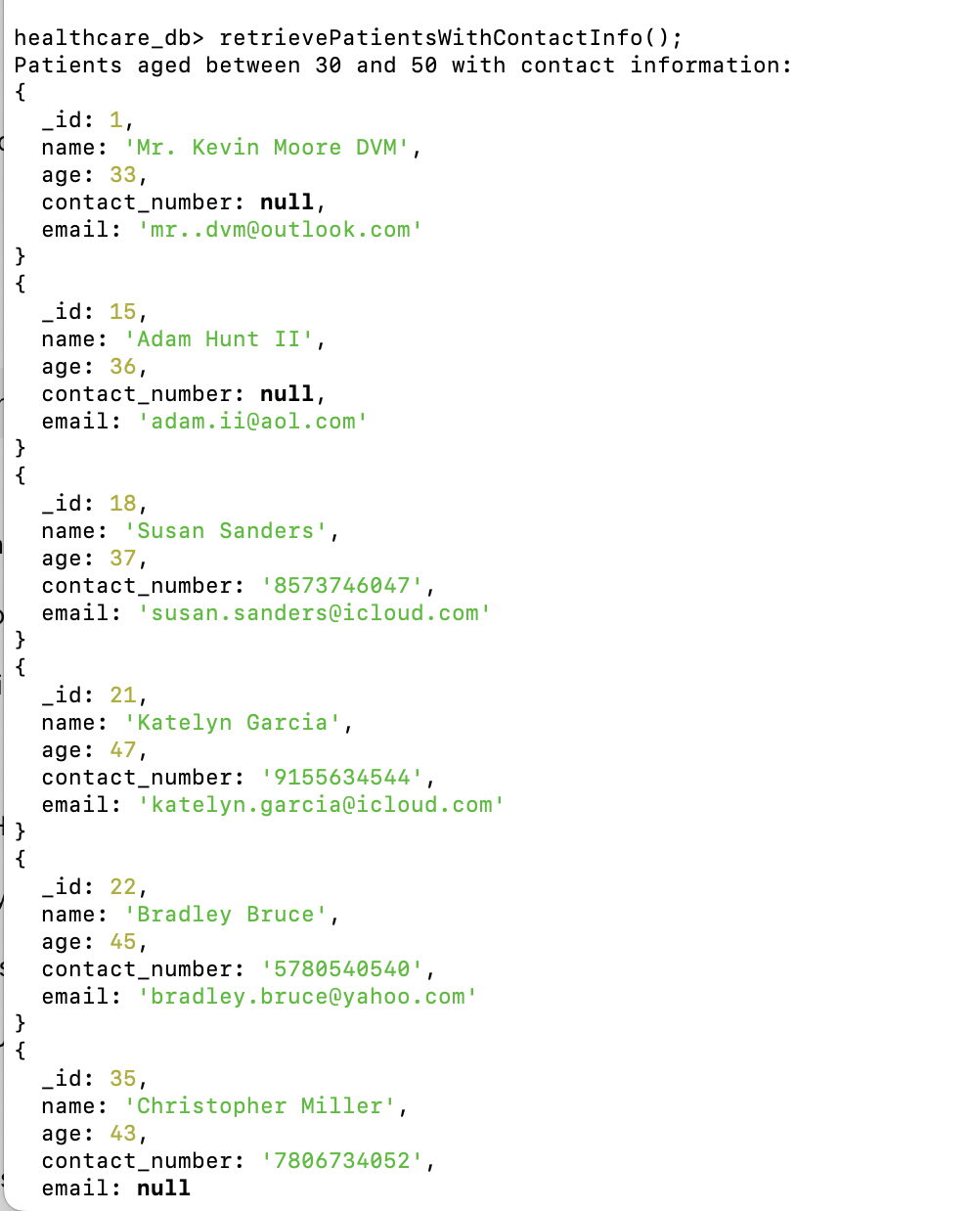

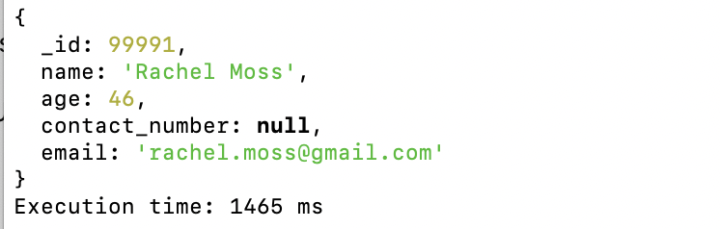

Task12:

List Appointments Marked as Follow-Up

Objective: Identify and list all appo function listFollowUpAppointments() {

const startTime = new Date();

// Find all appointments marked as follow-up

const followUpAppointments = db.Appointments.find({

is_follow_up: true

}).toArray();

// Print the details of follow-up appointments

print("Follow-up Appointments:");

followUpAppointments.forEach(appointment => {

printjson({

_id: appointment._id,

patient_id: appointment.patient_id,

date: appointment.date,

is_follow_up: appointment.is_follow_up, // Include the follow-up status

symptoms: appointment.symptoms,

treatment_details: appointment.treatment_details

});

});

const endTime = new Date();

const executionTime = endTime - startTime;

print(`Execution time: ${executionTime} ms`);

}

// Call the function

listFollowUpAppointments();intments that have been marked as follow-up for easy tracking.

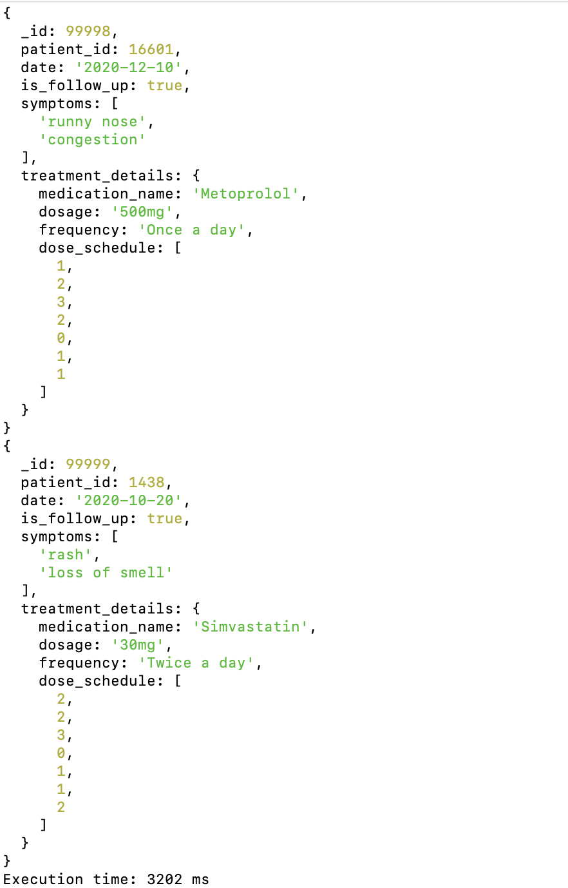

Task13

Retrieve All Patients' Names and Ages (Extra credit)

Objective: Extract and display the names and ages of all patients.

MongoDB:

Not sure what kind of output professor is looking for so I did two version

First version

function retrieveAllPatientsNamesAndAges() {

const startTime = new Date();

// Retrieve all patients' names and ages

const patients = db.Patients.find(

{},

{ name: 1, age: 1, _id: 0 } // Project only name and age, exclude _id

).toArray();

// Print the retrieved patients' names and ages

print("Patients' Names and Ages:");

patients.forEach(patient => {

printjson(patient);

});

const endTime = new Date();

const executionTime = endTime - startTime;

print(`Execution time: ${executionTime} ms`);

}

// Call the function

retrieveAllPatientsNamesAndAges();

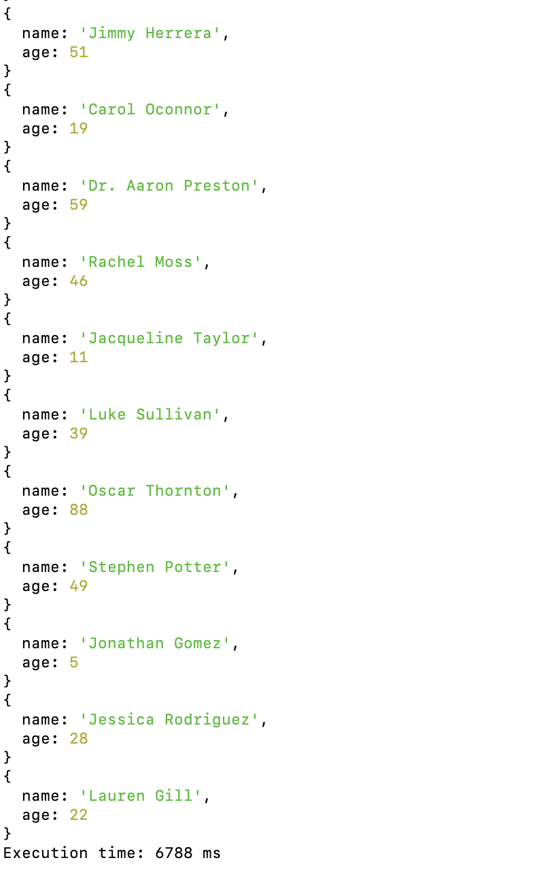

Second Version:

function retrievePatientsNamesAndAgesSeparately() {

const startTime = new Date();

// Retrieve all patients' names and ages

const patients = db.Patients.find({}, { name: 1, age: 1, _id: 0 }).toArray();

// Separate names and ages into individual lists

const names = patients.map(patient => patient.name);

const ages = patients.map(patient => patient.age);

// Print the names list and ages list

print("List of Patients' Names:");

printjson(names);

print("List of Patients' Ages:");

printjson(ages);

const endTime = new Date();

const executionTime = endTime - startTime;

print(`Execution time: ${executionTime} ms`);

}

// Call the function

retrievePatientsNamesAndAgesSeparately();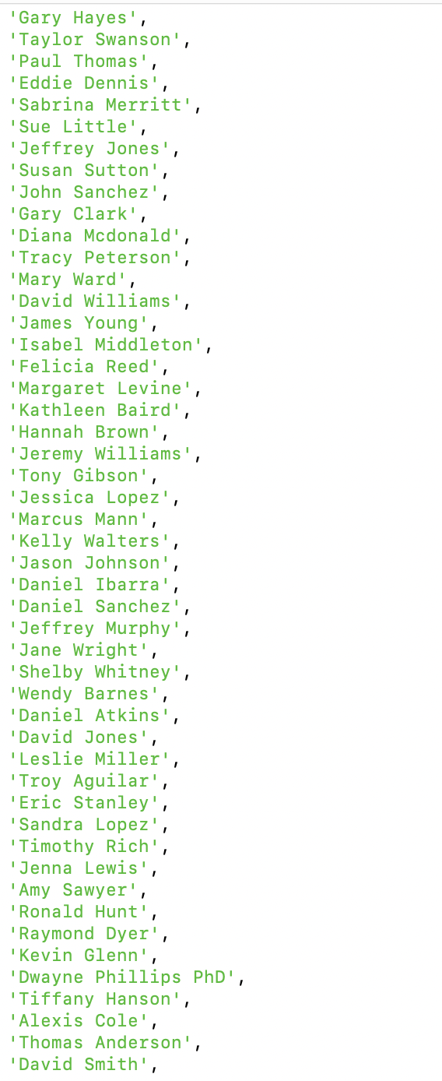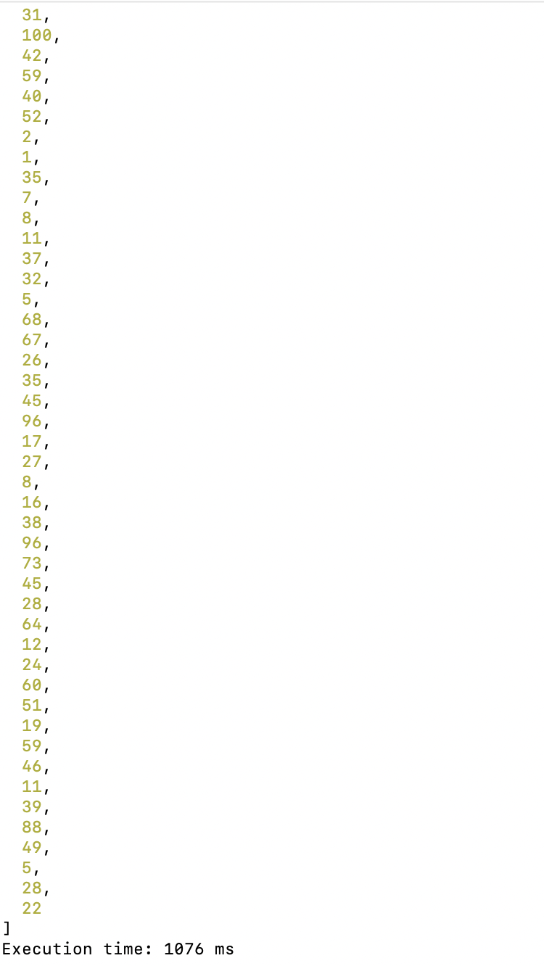

Task14

Find Appointments with Symptoms in an Array

Objective: Identify appointments where symptoms are stored in an array format.

function findAppointmentsWithSymptomsInArray() {

// Find all appointments where 'symptoms' field is an array

const appointmentsWithArraySymptoms = db.Appointments.find({

symptoms: { $type: "array" }

}).toArray();

// Print the result with only the relevant fields (_id, symptoms)

print("Appointments where symptoms are stored in an array:");

appointmentsWithArraySymptoms.forEach(appointment => {

printjson({

_id: appointment._id,

symptoms: appointment.symptoms

});

});

}

// Call the function

findAppointmentsWithSymptomsInArray();

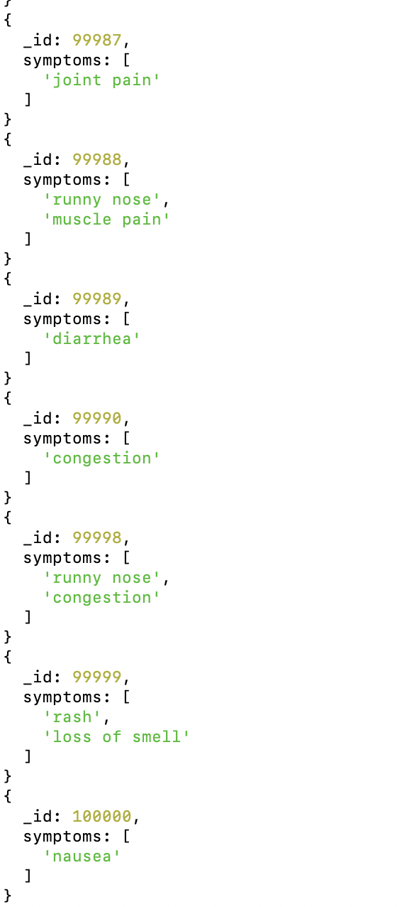

Task15

Retrieve Patients with Names Starting with Specific Letters Using Regular Expressions

Objective: Find patients whose names start with certain letters using regex matching.

I choose to find patients name start with letter A

function findPatientsWithNamesStartingWith(letter) {

// Find patients whose names start with the given letter using a case-insensitive regex

const regex = new RegExp(`^${letter}`, 'i'); // The ^ denotes the start of the string, 'i' makes it case-insensitive

const patients = db.Patients.find({

name: { $regex: regex }

}).toArray();

// Print the details of patients

print(`Patients with names starting with '${letter}':`);

patients.forEach(patient => {

printjson({

_id: patient._id,

name: patient.name,

age: patient.age,

contact_number: patient.contact_number,

email: patient.email

});

});

}

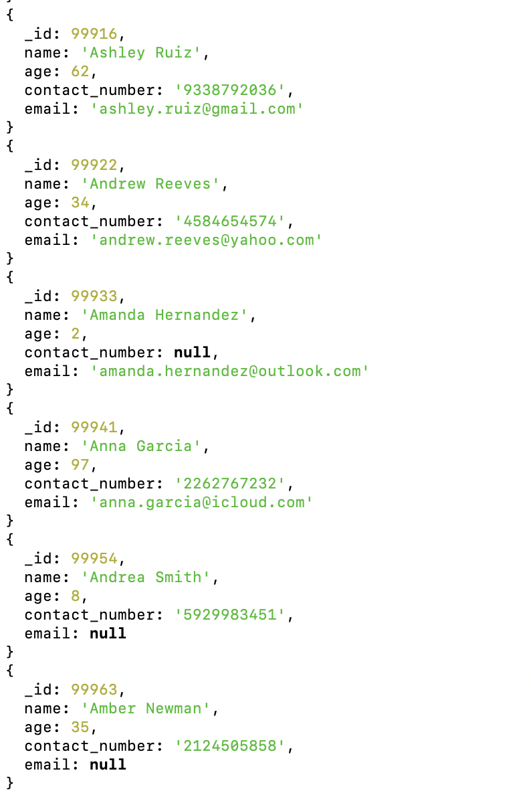

Task16

function updateMedicationDosageForCondition() {

// Step 1: Retrieve and print 5 examples of appointments before the update

const appointmentsBeforeUpdate = db.Appointments.find({

symptoms: "fever",

"treatment_details.medication_name": "Ibuprofen"

}).limit(5).toArray();

print("Examples of Appointments before the dosage update:");

appointmentsBeforeUpdate.forEach(appointment => {

printjson({

_id: appointment._id,

symptoms: appointment.symptoms,

treatment_details: appointment.treatment_details

});

});

// Step 2: Update the dosage for all matching appointments

db.Appointments.updateMany(

{

symptoms: "fever",

"treatment_details.medication_name": "Ibuprofen"

},

{

$set: { "treatment_details.dosage": "400mg" }

}

);

// Step 3: Retrieve and print 5 examples of appointments after the update

const appointmentsAfterUpdate = db.Appointments.find({

symptoms: "fever",

"treatment_details.medication_name": "Ibuprofen"

}).limit(5).toArray();

print("Examples of Appointments after the dosage update:");

appointmentsAfterUpdate.forEach(appointment => {

printjson({

_id: appointment._id,

symptoms: appointment.symptoms,

treatment_details: appointment.treatment_details

});

});

}

// Call the function

updateMedicationDosageForCondition();

